Emerging Global Diamond Markets:

2011 Bain & Company report indicates $15 Billions market produced 124 carats of rough diamonds by various companies like ALROSA, BHP Billiton, De Beers, Rio Tinto etc.

But recently in 2020, Diamond jewelry sales dropped by 14% with a sales decline of 31%. Year 2021, Diamonds demand was recovering, especially 2nd half of the year.

Why Blockchain in Diamond industry?

* Transparency, traceable and permanent record.
* Supply chain visibility.
* Sustainability.
* Consumer Confidence.

Blockchain Start-ups Aims to Open the $1T Diamond Market to Investors Transforming the industry and Tokenized Commodities.

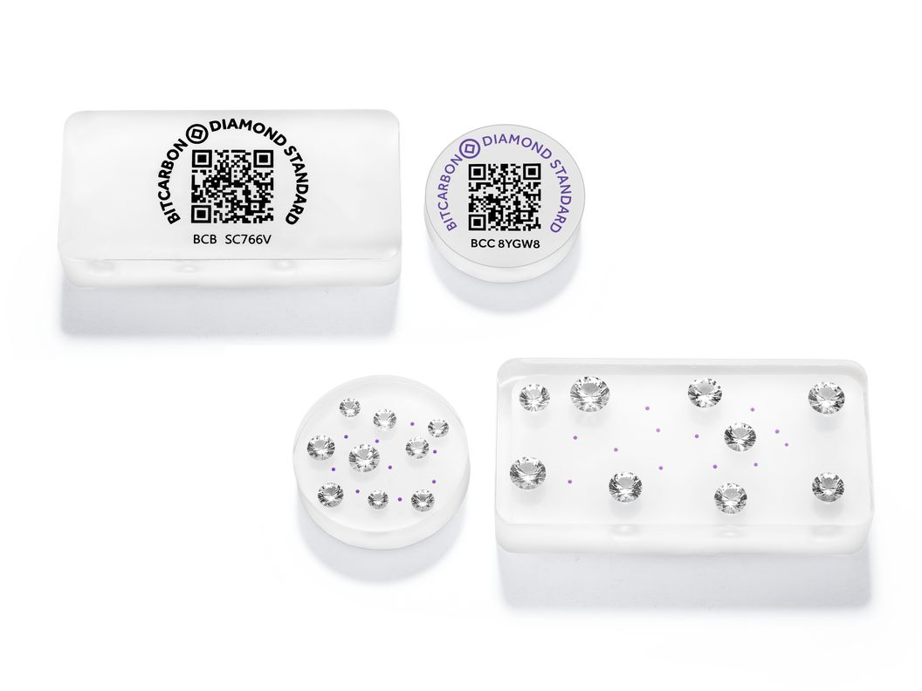

**Tokenization & NFT for Diamonds:**

2 types of Tokenization:

1. Fungible token: ERC20 as investment tool, value based on a diamond.
2. Non-fungible token, NFT ERC721 token:

Certification number is engraved on a diamond (GI), Certificate has the information, hologram. Digital copy of Certificate can be issued as NFT, no value. This NFT is just a tool to identify ownership of the diamond.

Diamond Standard is using regular tokenization to create a fungible product (a “diamond” coin), each made up of collections of five or six individual diamonds encased in a package.

Reasons:

* Diamonds /gemstones are very small, difficult-to-track items, and blockchain technology and tokenization add real value to our industry. This makes the product more attractive, as it has the potential of adding transparency and integrity to the process.
* Once tokenized, diamonds can be kept in a secure vault, sold on a crypto-exchange, or withdrawn and kept in their owner’s safekeeping and give diamonds Liquidity.
* Also, Once Tokenized, in the global market, diamonds can be traded on any crypto exchange in the world that supports the ERC721 standard.

Sample GIA certificates:

Usage of Tether for Diamonds:

Tether is an asset backed Crypto currency with full transparency.

Tether is a fiat-collateralized stablecoin, which is a type of stablecoin that is backed by a fiat currency like USD, CAD, AUD, or even Yen (JPY). Tether was created to bridge the gaps between fiat currencies and blockchain assets while offering transparency, stability, and low fees for USDT users. Tether is pegged against the U.S. Dollar at a 1:1 ratio. There is no guarantee from Tether Ltd. for any right of redemption or exchange of Tether to USD. USDT cannot be exchanged directly for USD through the Tether company.

Currently Diamonds are traded as Diamond XRPL expressed in tether.

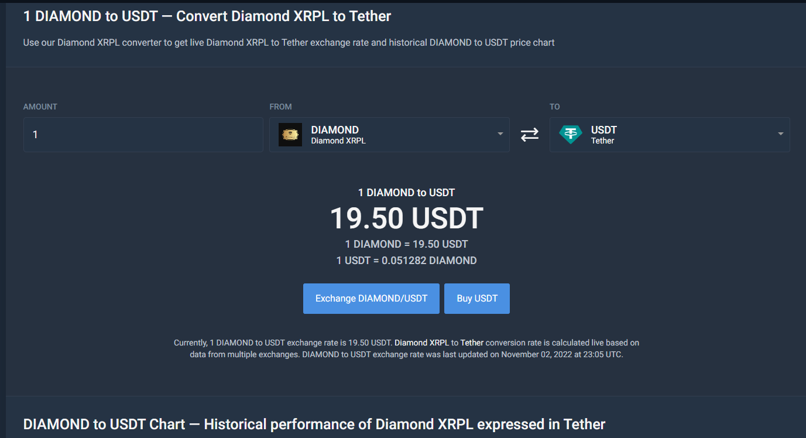

The value of tether can be exchanged in various major currencies-based rate fluctuations.

